**National College of Ireland**

**MSc in Web Technologies**

**2013/2014**

**ARIA**

**Project – Loyalty Card Holder**

**Entaria**



**Hugh Kelly 13117386**

**Adrian Mann 12110701**

**Brendan O’Brien 13122096**



Contents

1 Motivation 3

2 State Of The Art Review 4

3 User Interface Design 5

4 Architecture 7

4.1 Application Architecture: 7

4.2 Security: 7

4.3 Toolkits and Frameworks: 7

4.4 Data Transfer Strategies: 7

4.5 Evaluation and Testing: 7

5 Summary 8

References 9

# Motivation

# State Of The Art Review

Text.

**Table 1.** Popularity o as shown by web search on Sun 2nd March 2014.

|  |  |  |
| --- | --- | --- |
| Item | Search Engine | Number of Hits |
| “red” | Google | 3,600,000 |
|  | Bing | 2,035,000 |
| “blue” | Google | 1,196,000 |
|  | Bing | 1,213,000 |
| “green” | Google | 1,437,000 |
|  | Bing | 127,200 |
| “black” | Google | 3,760,000 |
|  | Bing | 392,000 |

Text text text text text text text text text text text text text text text text text text text text text text text text text text text text text text text text text text text text text text text text text text text text text text text text text text text text text text text text text text text text text text text text text text text text text text text text text text text text text text text text text text text text text text text text text text text text text text text text text text text text text text text.

# User Interface Design

The User Interface design for the ARIA continuous assessment was undertaken in conjunction with the Enterprise Frameworks project. In the formative stages of the development process we completed initial sketches of a possible user interface design and we refined these sketches through the wire framing process using the Balsamiq software package. An example of the sketches that were done can be found below in Figure 3.1.

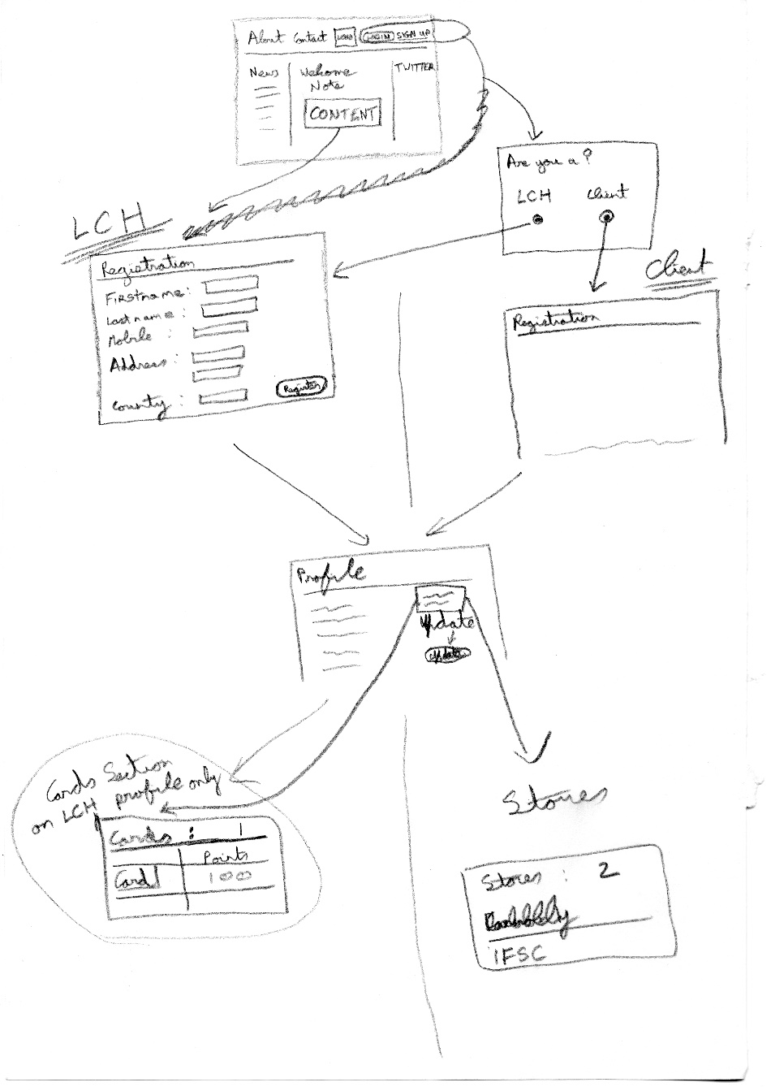

Figure 3.1

As mentioned above, these sketches were further enhanced in the higher fidelity wire frames that were produced with Balsamiq and an example of the home page wire frame can be seen in figure 3.2 below.

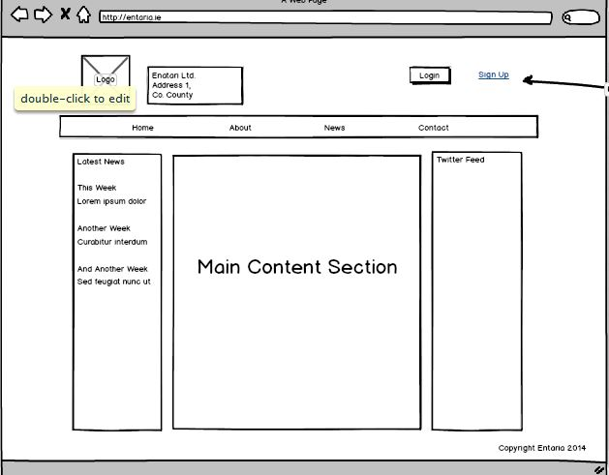

Figure 3.2

Due to the agile nature of our development process it is evident that there were some adjustments made between the first and second stages of the user interface design process. This pattern was continued as we implemented our interaction design strategy. Therefore, the result that we have deployed contains some features that were not including in the original mock ups and/or sketches. However, these have not only improved the design of the application but also show cased some of the technologies that we have encountered in tutorials and lectures. The final home page design can be seen inn Figure 3.3 below.

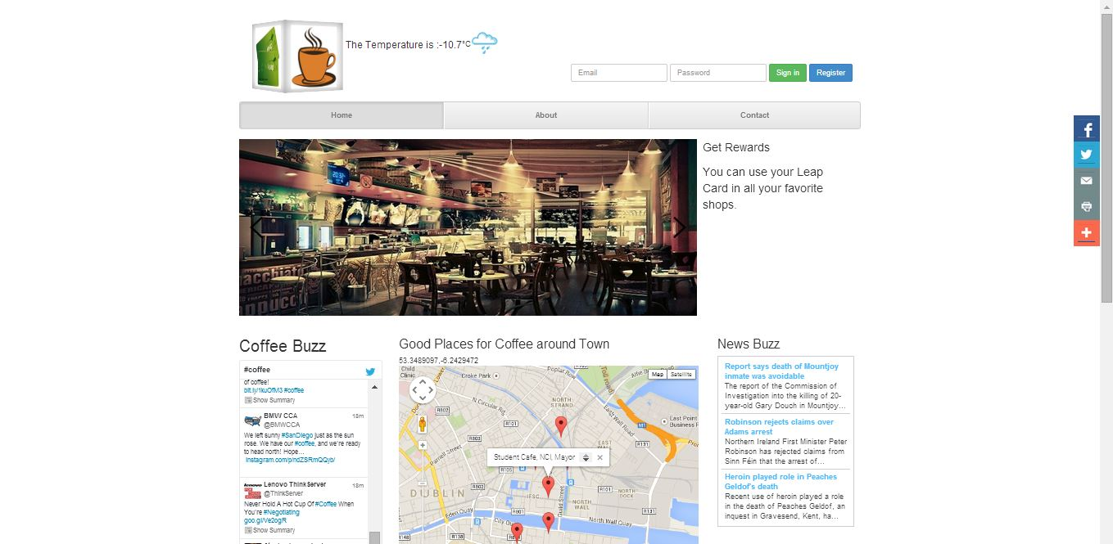

Figure 3.3

The layout of the site and the responsiveness have been implemented with the Twitter Bootstrap front end framework. This framework will reduce the work load in terms of designing a layout that is interactive and provided a large amount of sleek styling.

The final layout incorporates many features of a modern website in a style and format that is familiar to users of web applications yet one that we anticipate will be suitable in the year 2022. As is evident in the image of the homepage above, the basic layout shows a header with navigation, a slider and basic three column layout.

The theme of the site and the nature of the application that we are providing was heavily focused on and is evident throughout the style of the application. The theme of coffee is also noticeable in the news, twitter feed, weather, google map coffee shop locations and data display on the homepage.

## User Interaction Design Strategies

## User Testing

The user testing focused on a think aloud process. I have documented the scenarios below that our users had to undertake.

**Think Aloud**

**Scenario 1**

Navigate to the Coffee Sales section of the website. View the data that is displayed on the doughnut chart that is displayed. Identify the buttons above the chart and click on one of your choice to display the same information in a different style of graph.

**Scenario 2**

Navigate to the Twitter section of the website. View the Tweets that are displayed and navigate with through the list of coffee related tweets.

**Scenario 3**

Navigate to the header section of the website and identify the menu navigation. Click on the “Contact” tab. When you are taken to the “Contact” page, identify the Contact form. Enter your details into this form and hit submit.

**Cam Studio Screen Recording**

Each user who completed the Think Aloud testing was recorded using the Cam Studio software.

**Satisfaction**

Each user was also asked each participant in the study to complete as systems usability test. The test is documented below.

|  |  |  |  |  |  |
| --- | --- | --- | --- | --- | --- |
|  | Strongly disagree 1 | 2 | 3 | 4 | Strongly agree 5 |
| 1. I found the system unnecessarily complex. |  |  |  |  |  |
| 1. I thought the system was easy to use. |  |  |  |  |  |
| 1. I think that I would need the support of a technical person to be able to use this system. |  |  |  |  |  |
| 1. I found the various functions in this system were well integrated. |  |  |  |  |  |
| 1. I thought there was too much inconsistency in this system. |  |  |  |  |  |
| 1. I think that I would like to use this system frequently. |  |  |  |  |  |
| 1. I would imagine that most people would learn to use this system very quickly. |  |  |  |  |  |
| 1. I found the system very cumbersome to use. |  |  |  |  |  |
| 1. I felt very confident using the system. |  |  |  |  |  |
| 1. I needed to learn a lot of things before I could get going with this system. |  |  |  |  |  |

# Architecture

## Application Architecture:

Outline the solution architecture for your application. You should justify the approach you took, and how it supports the project scope. This means mapping back to the state of the art review when describing the features and functionality of your system.

## Security:

Evaluate industry standard error handling, and outline how you integrated these approaches within your application.

## Toolkits and Frameworks:

Discuss the toolkits and frameworks used and the justification for using them.

## Data Transfer Strategies:

This section looks at the access and transporting of data to be consumed/created by the RIA.

## Evaluation and Testing:

You must include a short description of how your application was evaluated for its audience.

Critically analyse the testing methodology employed, as well as any debugging

# Summary

More of the same

# References

1. Bango, R., 2013. *Getting into Ember.js* [online] Available at http://code.tutsplus.com/tutorials/getting-into-ember-js--net-30709 [accessed 7h March 2014]

2. Emberjs.com, 2014. *SEE WHO'S USING EMBER.JS* [online] Available at http://emberjs.com/ember-users/ [accessed 15th March 2014]

3. Gamma, E. et al., 1995. *Design Patterns: Elements of Reuseable Object-Oriented Software,* Addison Wesley, New York, p.293-303

4. Google Inc., 2014. *What is Angular?* [online] Available at http://docs.angularjs.org/guide/introduction [accessed 6th March 2014]

5. Green, B., Seshadri, S., 2013. *AngularJS*, O'Reilly, Sebastopol, CA, USA. p.5

6. Hardy, I., 2012. *Coding the future: HTML5 takes the internet by storm* [online] Available at http://www.bbc.com/news/business-17931814 [accessed 6th March 2014]

7. Knockoutjs.com, 2014. *Documentation* [online] Available at http://knockoutjs.com/documentation/introduction.html [accessed 7th March 2014]

8. Maslow, B., 2013. *Knockout vs Angular* [online] Available at http://www.slideshare.net/MaslowB/knockout-vs-angular [accessed 14th March 2014]

9. Meliá, S. et al., 2010. *Automatic Selection of RIA Software Architectures using Quality Models*, Seventh International Conference on the Quality of Information and Communications Technology.

10. Osmani, A., 2012. *Journey Through The Javascript MVC Jungle* [online] Available at http://coding.smashingmagazine.com/2012/07/27/journey-through-the-javascript-mvc-jungle/ [accessed 6th March 2014]

11. Osmani, A., 2013. *Developing Backbone.js Applications,* O'Reilly, Sebastopol, CA, USA.

12. Reenskaug, T., 2003. *MVC – Xerox Parc 1978-79* [online] Available at http://heim.ifi.uio.no/~trygver/themes/mvc/mvc-index.html [accessed 6th March 2014]

13. Sanderson, S., 2012. *Rich JavaScript Applications – the Seven Frameworks (Throne of JS) 2012* [online] Available at http://blog.stevensanderson.com/2012/08/01/rich-javascript-applications-the-seven-frameworks-throne-of-js-2012/ [accessed 6th March 2014]

14. Smith, J., 2009. *WPF Apps With The Model-View-ViewModel Design Pattern* [online] Available at http://msdn.microsoft.com/en-us/magazine/dd419663.aspx [accessed 6th March 2014]